ECG-1210 Digital 12-channel ECG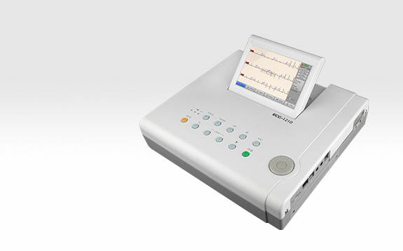

Features:
• 7-inch LCD with foldable screen about 80 degree
• Functional shortcut keys and rotation knob, easy in operation
• Neat menu design delivers a delightful and user-friendly operation experience
• Automatic measurement and interpretation proved by CSE / AHA / MIT database
• Broad frequency response 0.05~250Hz for weaker signal recognition and capture, more suitable for pediatrics
• Real-time waveform freezing available
• Up to 300 seconds R-R analysis for easier in arrhythmia locating
• Massive local storage for up to 1500 files
• Auto-trigger printing when arrhythmia is detected
• Data auto save to simplify workflow
• Report preview before printing
• Printing on A4 size thermal paper under economic mode
• Multiple report formats: simple / detail / median beat reports
• ECG management software (optional)

